Group Discussion Guide

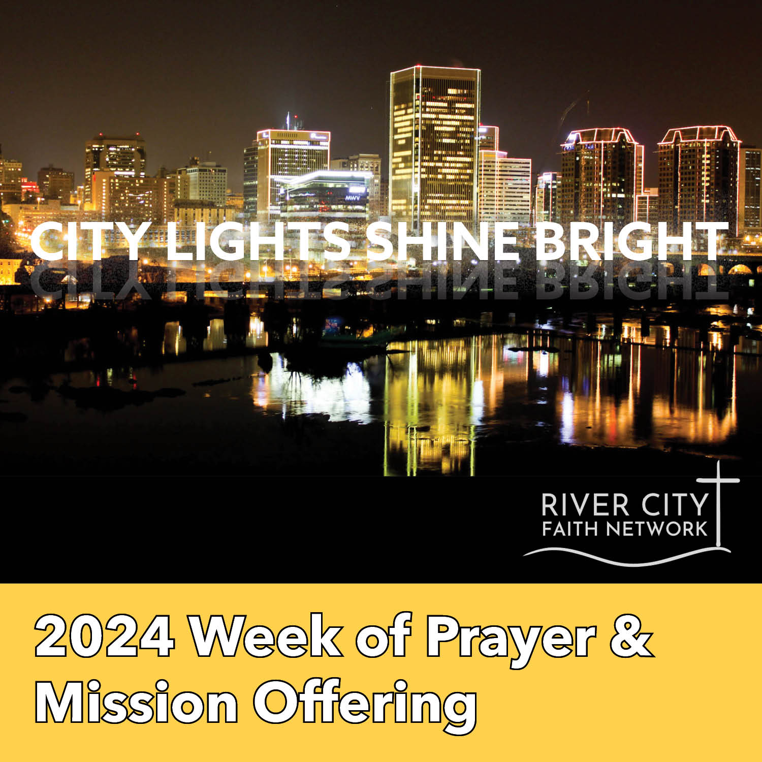

“Here’s another way to put it: You’re here to be light, bringing out the God-colors in the world.
God is not a secret to be kept. We’re going public with this, as public as a city on a hill. If I make you light-bearers, you don’t think I’m going to hide you under a bucket, do you? I’m putting you on a
light stand. Now that I’ve put you there on a hilltop, on a light stand—shine! Keep open house;
be generous with your lives. By opening up to others, you’ll prompt people to open up with God,
this generous Father in heaven.” (Matthew 5:14-16 The Message)

The River City Faith Network is a diverse family of churches working together to transform our communities through the love of Christ and for the Glory of God.

GROUP DISCUSSION LEADER’S GUIDE

OBJECTIVE: To promote awareness and engagement in the River City Faith Network ministries and offering allocations.

GOALS:
- Participants will learn about the camp & ministry center offering allocations.

- Participants will discuss the needs and help offered through the camp and ministry centers.

- Participants will be encouraged to pray for, give to and engage in the needs and resources of the RCFN ministries.

MATERIALS PREPARATION:

- Copy/obtain a Week of Prayer Guide for each participant.
- Download or obtain a copy of the Week of Prayer video www.richmondbaptist.org
- Print copies of the allocation discussion handouts.
- Print copies or display on screen the Circle of Light Responsive Reading.
- Copy and cut apart light cards – one for each participant.

ADDITIONAL MATERIALS AVAILABLE:

- Individual center and camp videos on RCFN website and RCFN onYouTube
- Children’s Mission Guide and VBS Mission Moments
- Posters, Bulletin Inserts, Offering envelopes, Social Media graphics

GROUP ARRANGEMENT:

- Divide participants into 7 groups of 4-6.
- For gatherings of less than 15 people, work in pairs to discuss allocations.

DISCUSSION FORMAT:

Opening activity: Turn the Lights On (5 minutes)
Introduction: Video & Theme and Allocations Overview (10 minutes)
Allocation Activity: Small group discussion & prayer (15 minutes)
Closing: Circle of Lights Responsive Reading (5 minutes)

OPENING ACTIVITY: Turn The LIGHTS On (5 minutes)

- Distribute one light card to each participant.
- In your small group please share:
  - Type of light on your card
  - What image or memory does it bring to mind?
  - How does that light apply to missions, discipleship, or outreach?

Example: A porch light reminds me of home and someone waiting for me.
Mission is like a porch light as we keep the light on to welcome the
stranger or provide a place that is welcoming, feels like home.

- Invite several people to share their responses.

INTRODUCTION: Theme and Allocations Overview (5 minutes)

- Show the Week of Prayer Video OR
- Present the following information to the group

Week of Prayer & Mission Offering
May 5-12, 2024
“If we walk in the light, as he is in the light, we have fellowship with one another.” I John1:7
If you’ve ever been alone in the pitch dark, you know how comforting one speck of light may be. Nightlights, porchlights, and searchlights illuminate our space, provide us with a sense of peace and guide us with their glow. Matthew 5:14 tells believers that we are the “light of the world—like a city on a hilltop that cannot be hidden”. Our collective light, the fellowship among our RCFN churches, is a witness to our city and shines through our ministry centers, camp and congregational connections that transform our city.

City Lights Shine Bright 2024 Goals:
100% of RCFN Churches praying, giving, and engaging in RCFN ministries
$50,000 Week of Prayer Offering $5,000 Children & Youth Offering

This year our Week of Prayer requests and offering allocations will shine the light in our camp, centers, congregations, clergy, and community.
Your prayers and gifts will support:

Camp Alkulana –
- Youth Mental Health First Aid Training - Camp Alkulana Summer Program Staff
- Youth Leadership Development – Camp Alkulana LEADS

Ministry Centers -
- Furniture and Clothing Evangelism (FACE) Ministry Resources - SRBC
- Encouraging Financial Literacy - Church Hill Christian Wellness Center
- Loads of Love Unhoused Laundry Ministry Expansion – OHBC

Congregational Connections –
- Ministry Leadership Gatherings
- Clergy Pastoral Intelligence book discussion

Community Collaboration -
- Creating a Reconciling Community Cohort
- Domestic Missions Partnership Development

ALLOCATION ACTIVITY: Give each group copies of a different allocation. (15 mins.)

- Read the allocation description.
- Discuss the related questions.
- Consider how you, your church, your group might engage in the ministry.
- Spend time in prayer for the ministry.

CLOSING: Invite the group to stand in a circle & read Circle of Light litany

INVITATION TO GIVE: Please share the ways in which participants may give to the
Week of Prayer Offering

Online: www.richmondbaptist.org

QR Code

Through your church Week of Prayer offering

ADDITIONAL RESOURCES: Please share this information with participants!

Individual videos of each center and camp ministry are available on the RCFN website and YouTube www.richmondbaptist.org

Porch Light | Sunlight | Searchlight
Streetlight | Flashlight | Spotlight
Nightlight | Candlelight | Firelight
String Lights | Holy Light | Starlight
Moonlight | City Lights | Red Light
Green Light | Black Light | Yellow Light
House light | Lamplight | Headlights

LOADS OF LOVE LAUNDRY MINISTRY
The Oregon Hill Baptist Center along with volunteers and many church partners have been ministering to the unhoused of Richmond for many years. The ministry involves a sit-down meal once a week as well as offering a clothing closet, a mailing address, and a locker room specifically for those who are without housing. An additional program that is offered is the opportunity for the same individuals to wash their clothes once or twice a month. Our laundry program is run in partnership with St. Andrew’s Episcopal Church which is also located in the neighborhood of Oregon Hill. Participants meet volunteers at a local laundromat twice a month and are given money and detergent to wash and dry 1 load of clothes. This averages out to be approximately $65 per wash day. Volunteers remain present to socialize, pray, and offer assistance to those who have come to wash. A portion of this years’ Week of Prayer Offering will be designated to assist in the ongoing costs of our Laundry Program. It is our hope that we may be able to offer the laundry program to more participants by increasing the number of days it is offered.

INVITATION TO DISCUSS:
- In what ways can doing a load of laundry assist in bringing hope and well-being to a person’s life?
- What other basic needs does the Oregon Hill Center assist with and how can they have an impact on the recipients as well as the volunteers?
- In what ways can our church connect with the community around us to bring hope, well-being, and have a positive impact?

INVITATION TO ENGAGE:
- Assist in providing and serving a potluck meal on a Friday Community Movie Night in Oregon Hill this spring or summer.
- Bring a group on a Thursday morning to assist in serving breakfast to our program participants. Contact Jennifer for open dates.

INVITATION TO PRAY:
- An overwhelming response to our offering this year so that the exciting new and existing ministries of our Centers and Camp can be well funded to make it possible to reach and increase those we serve.
- The City of Richmond and surrounding area government leaders, others, and ourselves to realize the crucial need for affordable housing in our area and to work towards switching the trend of ever rising housing costs.
- Those who live a life of daily uncertainty regarding their own safety, health, and shelter due to a lack of income, support systems, medication, and community resources.

CONTACT: Rev. Jennifer Turner, Oregon Hill Baptist Center Director
804.329.1701 jennifer.turner@rbaonline.org
YOUTH MENTAL HEALTH FIRST AID

Like many summer camps, Camp Alkulana has seen a rise in mental health concerns among campers and counselors in the past five years. Each of staff participate in a twelve-day staff training program, and for many years that has contained a mental health component. Given the current challenges we see among our campers, we would like to enhance our training by utilizing an industry best practice model, Mental Health First Aid. To make this economical for years to come, our camp director, Beth Wright, will receive training to lead the course and then will train and certify her summer staff during the summer staff training period. The training and materials are costly and not included in our annual budget. This would be a great project to include in the RCFN Missions offering this year.

INVITATION TO DISCUSS:

- What might be some of the mental health concerns our campers and counselors deal with?
- How is the camp experience beneficial to improving mental health?

- How can you or the church encourage mental health and well-being?

INVITATION TO ENGAGE:
- Volunteer at a workday at Camp this spring (May 18 or June 1)
- Attend a Day of Camp this summer (TBD)
- Help on the camp bus stop days (June 16, July 1, July 15, July 30)
INVITATION TO PRAY:

- For our summer staff who will serve at Camp Alkulana this summer.
- For our families who are getting ready to send their children away to camp.
- For a safe summer, filled with fun, growth, and healing.

CONTACT: Beth Wright, Camp Alkulana Director
804.329.1701 bwright@alkulana.org

CAMP ALKULANA LEADS

The Alkulana LEADs program offers leadership development for former Alkulana campers (ages 14-18). Throughout the year, participants engage in opportunities to LEAN into leadership roles, EXPLORE themselves and the world around them, take ACTION to better the world, and to engage in DIVERSE communities. We look for opportunities in the private and non-profit sectors to partner with us in these educational goals. In 2024, we hope to partner with HALT, an equine therapy experience that teaches leadership, teamwork, and healing. Students will participate in developing leadership skills, confidence, and resilience as they learn to engage horses in activities.

INVITATION TO DISCUSS:

- How did your church or someone in your life invest time to mentor you as a leader?
- What benefit does mentoring and leadership development offer the church?
- How might we connect these young leaders with our churches?

INVITATION TO ENGAGE:
- Provide a meal or snacks for one of the LEADs monthly meetings.
- Provide meeting space for one of our LEADs meetings in your church or business.

INVITATION TO PRAY:
- Pray for Kate as she LEADs our youth throughout the school year.
- Pray for our current LEADs students who are transitioning out of high school in May.
- Pray for our volunteers as they give of their time to invest in our LEADs students.

CONTACT: Beth Wright, Camp Alkulana Director
804.329.1701 bwright@alkulana.org

ENCOURAGING FINANCIAL LITERACY

The Church Hill Christian Wellness Center has been blessed with a young man who wants to volunteer by starting a Financial Literacy Class. This young man has experienced many hardships that were derived from street influences, bad choices, and rebellion against his upbringing. The combination of these things resulted in a few incarcerations. His last sentence robbed him of many years of freedom. However, while behind bars, he decided to make the best of a bad situation by learning new skills that he knew he would need after his release. One of those life skills was Financial Literacy; which he did not learn at home but now realizes its importance and how critical it is for parents to teach this at an early age.

He is now motivated to pass on the knowledge he gained. His hope is by sharing the importance of building credit, maintaining a bank account(s), learning to budget, invest, and manage debt, he will earn the trust of the next generation. Winning their trust will open a door for him to share his life’s experiences and help to prevent someone else from going down the same destructive and unproductive path that he chose.

INVITATION TO DISCUSS:

- Why is Financial Literacy important?

- At what age do young adults start making important financial decisions? What are some of those decisions they will need to make?

- Why is it important for CHCWC to implement a Financial Literacy Program?

INVITATION TO ENGAGE:
- Provide a snack or a meal for the meeting.
- Serve as a volunteer for the meeting.
- Volunteer for Community Fun Days
INVITATION TO PRAY:
- For our volunteers and the Financial Literacy Class
- For space to implement the class
- For the participants that the class will draw

CONTACT: Rev. Glinda Ford, Church Hill Christian Wellness Center Director
804.329.1701 glinda.ford@rbaonline.org

FURNITURE AND CLOTHING EVANGELISM (FACE)

South Richmond BC is requesting $5000 through the Associational Mission offering to be used for the new Furniture and Clothing Evangelism (FACE) Ministry. Since this is a brand-new ministry emphasis, we would like to request assistance in purchasing accessories that the new ministry will need.
Your gifts will be used for: (1) An Ironing board and Iron, (or Handheld Steamer or Steam Pressing unit) for the various clothing donated that are wrinkled. Our goal is to assist the participants in putting their best foot forward, as they may enter the work force or go for a job interview. (2) A Vacuum Cleaner is needed since the floor has carpeting. (3) Often, the donations come in not clean or become dirty in transition to the ministry. A Washer and Dryer would help with keeping the clothing clean. (4) Several Shoe Racks to display the donations in an orderly way. (5) Paper Caped Hangers with a Christian message printed representing the ministry and ways to pass the message on. (6) Furniture Dollies for moving furniture around the ministry center.

INVITATION TO DISCUSS:

- Why do we need this ministry for families around Richmond?
- What might cause someone to lose all their belongings?
- How might quality, clean clothing help someone?

INVITATION TO ENGAGE:

- Youth and mission teams can help keep the clothing closet in an orderly manner.
- Volunteers can help with furniture delivery and pick up and or delivery to homes.
- Build ongoing relationships to those we assist.

INVITATION TO PRAY:
- For FACE as we begin this new ministry to reach people for Christ.
- For the participants that might need furniture as they face evictions, and obstacles and difficulties during times of transitioning their belongings.
- For the ministry as we start receiving furniture to help families
- For the clothing ministry as we attempt to reach people in need of Christian love. Pray we start receiving clothing for our young people and infants so that they may feel comfortable with their new and used clothing.
- For those receiving furniture or clothing to ask Jesus in their heart and/or live for the Lord and return thanks to God.

CONTACT: Rev. Wesley Garrett, South Richmond Baptist Center Director
804.329.1701 wesley.garrett@rbaonline.org

CONGREGATIONAL CONNECTIONS
“The River City Faith Network is a diverse
family of churches working together to transform our communities
through the love of Christ and for the Glory of God.”
RCFN Mission Statement

As a family of churches, we connect and build relationships with one another as God does transformative Kingdom work in, among and through the Network. Through our Week of Prayer and Mission Offering we hope to strengthen our Congregational Connections and Community Collaboration.

Individually the RCFN churches shine their light through a host of ministry and mission efforts. They are active through gardening, food pantries, music, youth and children’s ministry, clothes closets, ESL, unhoused, refugee, and healthcare efforts just to name a few. What would it look like if we gathered our ministry leaders and formed a Network Collective for each area bringing practitioners together for idea sharing and imagining a cooperative effort?

Our RCFN pastors are leaders among leaders, sharing their gifts beyond their local congregations. Pastors and other clergy find self-care necessary for longevity in ministry. The Network would like to invest in clergy well-being through self-care groups, book discussions, workshops, sabbatical support, etc.

INVITATION TO DISCUSS:

- What are some of the congregational ministries around which a collective might be formed?
- How might the RCFN support clergy in their spiritual well-being?

INVITATION TO ENGAGE:

- Serve on a Network Collective and refer others interested in a particular ministry area.
- Serve on and Network Prayer team to support the work of the Network and churches.

INVITATION TO PRAY:

- Pray for our RCFN congregations as they seek to connect people with God & each other.
- Pray for the RCFN Clergy that they may find rest, renewal, and vision for God’s Kingdom.

CONTACT: Dr. Maria Lynn, RCFN Executive Director Mission Strategist
804.329.1701 maria.lynn@rbaonline.org
COMMUNITY COLLABORATION
“The River City Faith Network is a diverse
family of churches working together to transform our communities
through the love of Christ and for the Glory of God.”
RCFN Mission Statement

As a family of churches, we connect and build relationships with one another as God does transformative Kingdom work in, among and through the Network. Through our Week of Prayer and Mission Offering we hope to strengthen our Congregational Connections and Community Collaboration.

The RCFN churches shine their light collectively through our ministry centers and camp. Ministering among a diverse Richmond community requires cultural understanding and a contextual framework for mission. What would it look like if we intentionally took the time to understand one another and the unique contributions each brings to the fellowship table? Equipping our leadership teams to demonstrate the transforming power of reconciliation may be a good starting place to reimagine our place in the community.

Historically, Richmond Baptist Association not only reached throughout our neighborhoods but around the world forming mission partnerships in Liberia, Toronto, New York among others. Partnership missions teach us the importance of global friendship, mutuality in mission and solidarity in suffering. What would it look like to form a domestic mission partnership beyond the Richmond region?

INVITATION TO DISCUSS:

- What skills might we need to learn regarding the complicated nature of intercultural relationships?
- What have you learned through mission partnership experiences and how might that strengthen our Network and churches?

INVITATION TO ENGAGE:

- Consider participation in a Reconciling Community cohort or World Café conversation.
- Consider serving on a Domestic Mission Partnership development team.

INVITATION TO PRAY:

- Pray for our RCFN congregations as they seek to understand and honor the cultural and contextual differences, they each represent.
- Pray for the RCFN leadership as they discern how and where to invest their partnership efforts.

CONTACT: Dr. Maria Lynn, RCFN Executive Director Mission Strategist
804.329.1701 maria.lynn@rbaonline.org
CIRCLE OF LIGHT
RESPONSIVE READING

Leader: Jesus said, I am the light of the world. Whoever follows me will never walk in darkness but will have the light of life. (John 8:12)

Group: He came as a witness to testify concerning that light, so that through him all might believe. (John 1:7)

Leader: In him was life, and that life was the light of all mankind. (John 1:4)

Group: The light shines in the darkness, and the darkness does not overcome it. (John 1:5)

Leader: For you were once in darkness, but now you are light in the Lord. Live as children of light. (Ephesians 5:8)

Group: We do not belong to the night or to the darkness. (I Thess.5:5)

Leader: You are the light of the world.

Group: A city on a hill cannot be hidden. (Matthew 5:14)

Leader: In the same way let your light shine before others, that they may see your good deeds and glorify your father in heaven. (Matt. 5:16)

Group: Neither do people light a lamp and put it under a bowl. Instead, they put it on a stand, and it gives light to everyone in the house. (Matthew 5:15)

Leader: You are a chosen people, a royal priesthood, a holy nation, God’s special possession, that you may declare the praises of him who called you out of darkness into his wonderful light. (I Peter 2:9)

Group: If we walk in the light, as he is in the light, we have fellowship with one another, and the blood of Jesus, his Son, purifies us from all sin. (I John 1:7)
AMEN

